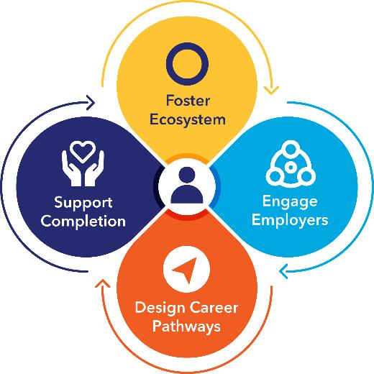
Framework for Career Pathways Alignment
LOCAL ACTION PLAN

Component 1: Foster Ecosystem/Partnership Building
What do we want to achieve?

What gaps and/or challenges do we want to address?

Action Steps:  How will we achieve it? | Roles/Responsibilities:  Lead/Team Member | Resources Needed: | Timeline:  By when? | Partners That Can Help: | Possible Funding Sources:
Framework for Career Pathways Alignment
LOCAL ACTION PLAN

Component 2: Engage Employers
What do we want to achieve?

What gaps and/or challenges do we want to address?

Action Steps:  How will we achieve it? | Roles/Responsibilities:  Lead/Team Member | Resources Needed: | Timeline:  By when? | Partners That Can Help: | Possible Funding Sources:
Framework for Career Pathways Alignment
LOCAL ACTION PLAN

Component 3: Design Career Pathways
What do we want to achieve?

What gaps and/or challenges do we want to address?

Action Steps:  How will we achieve it? | Roles/Responsibilities:  Lead/Team Member | Resources Needed: | Timeline:  By when? | Partners That Can Help: | Possible Funding Sources:
Framework for Career Pathways Alignment
LOCAL ACTION PLAN

Component 4: Support Completion
What do we want to achieve?

What gaps and/or challenges do we want to address?

Action Steps:  How will we achieve it? | Roles/Responsibilities:  Lead/Team Member | Resources Needed: | Timeline:  By when? | Partners That Can Help: | Possible Funding Sources:

